**Coursera Capstone**

**IBM Applied Data Science Capstone**

**The best neighborhood to open a restaurant in Boston city**

by Kessawa Palanund



**Introduction:**

In the business world, there is the most interesting question when people ask where should they open the business. It is the undeniable fact that the right place for business will always come with benefits such as more customers or more sales. It would be better if we use the customer generate data to decide the best place for a business instead of random choice and instinct. For example, we can find commonplace for restaurant type by using the data generated from Foursquare that defines the cluster by processing the code using python to show where in the neighborhood is restaurant cluster that customers will likely to go to find something to eat.

We will focus on Boston city as it is the largest city and the capital city of Massachusetts. There are also many people with a diversity of multinational.

In conclusion,we will try to use data from the Foursquare API to find the best neighborhood to open a restaurant in Boston city.

**Business problem:**

Ideally, we want to open a restaurant where there is a high population. This can be done by the use of data science methodologies where in the neighborhood is restaurant cluster that customers will likely to go to find something to eat in Boston.

**Data:**

In this report, we will data from Boston city's neighborhood to solve our problem. our data for analysis come from 4 sources.

First from Analyze Boston website we use Boston Neighborhoods Datasets to obtain a list of Boston neighborhood.

Second from Statistical Atlas website for our neighborhood population density data.

Third, we use geocoder package to obtain Latitude and Longitude Data from the name of each neighborhood.

and the last is from Foursquare API which we use to obtain data such as venue in each neighborhood and category of it.

**Methodology:**

1. First, I scraped data containing the city. After cleaning the data, I appended the latitude and longitude of the cities to the original data frame containing the citiy. Then, I used a folium module to plot the cities on the map to visualize the data.
2. Using the Foursquare API client ID, I collected the venues near Boston.
3. Using these frequencies, I made 4 clusters to identify which cluster had the highest and lowest restaurant.

**Results:**

Through clustering, we can find that there are 4 clusters.

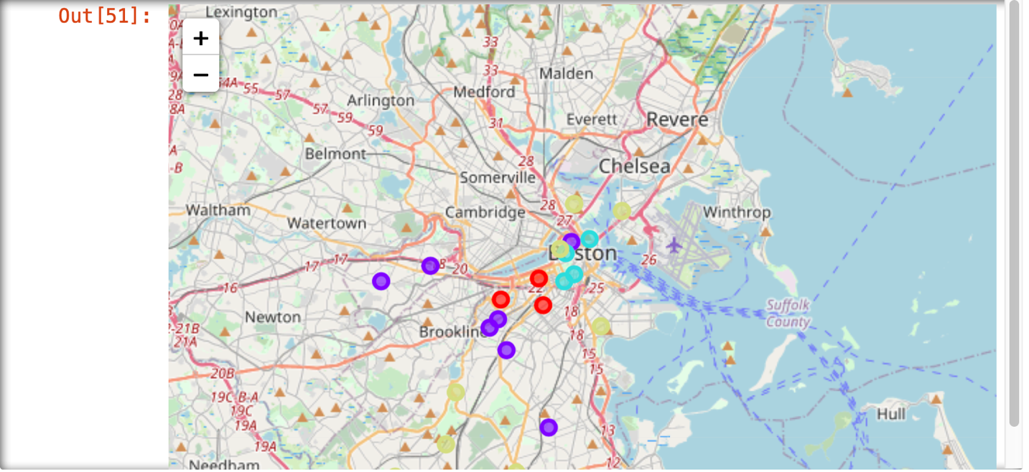

Cluster 1 which most common is Pizza place, café and Korean restaurant.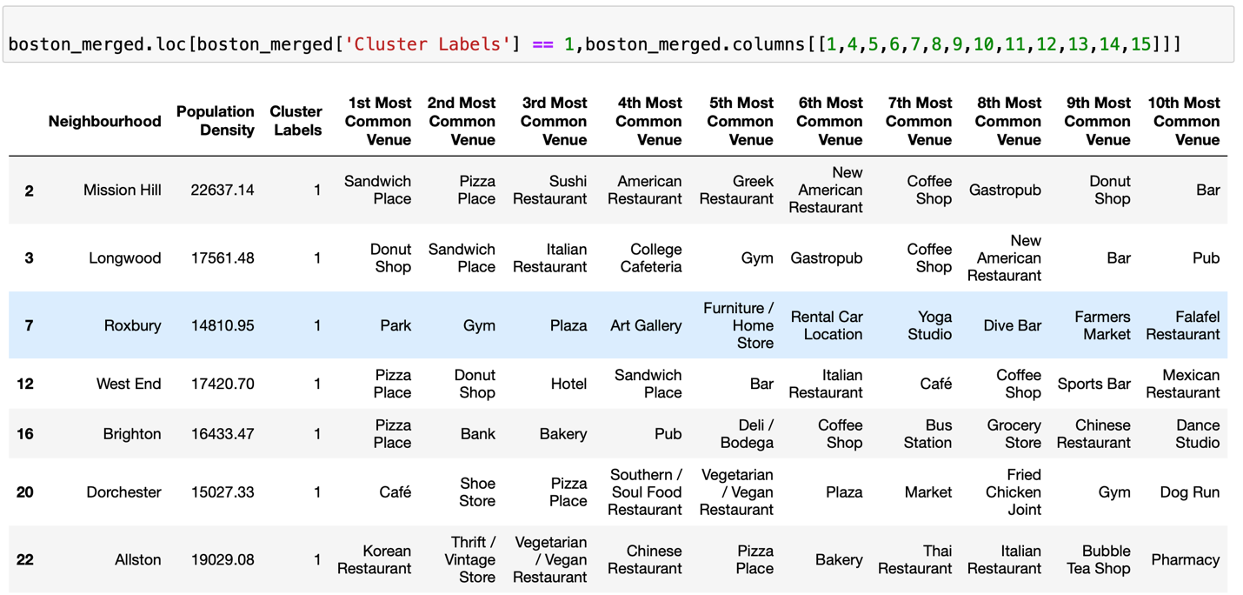

Cluster 2 which most common is Spa, Chinese and Italian restaurant.

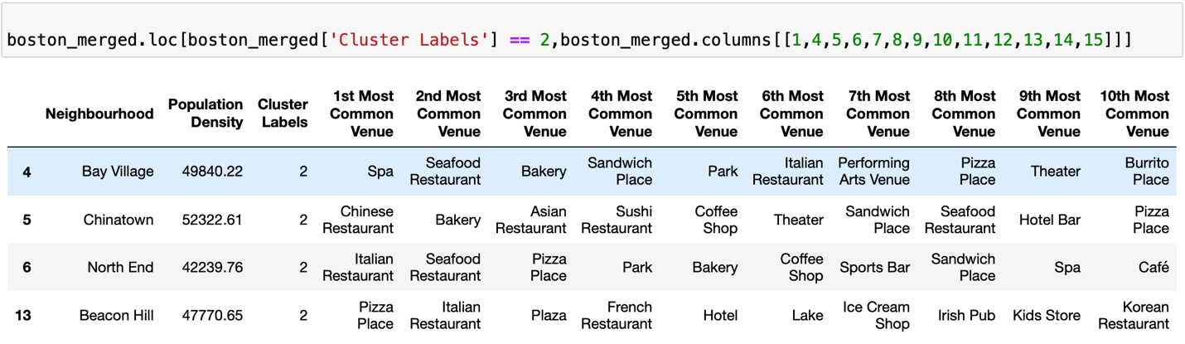

Cluster 3 which most common is Pizza place, Bakery and another variety of place such as Yoga, Playground, Pharmacy and home service.

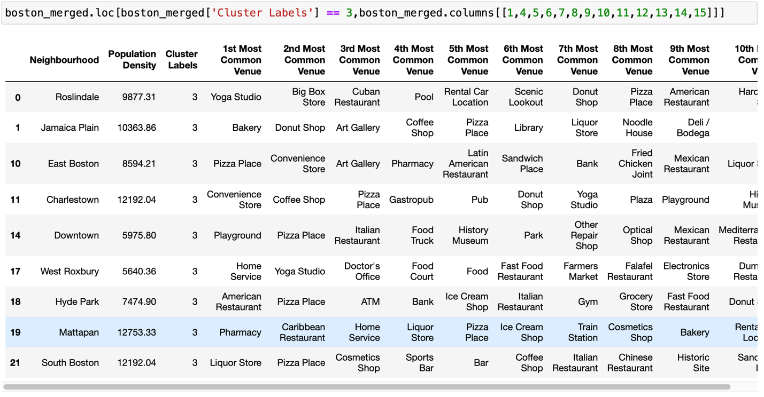

Cluster 4 which most common is Coffee shop, sports bar and Italian restaurant.

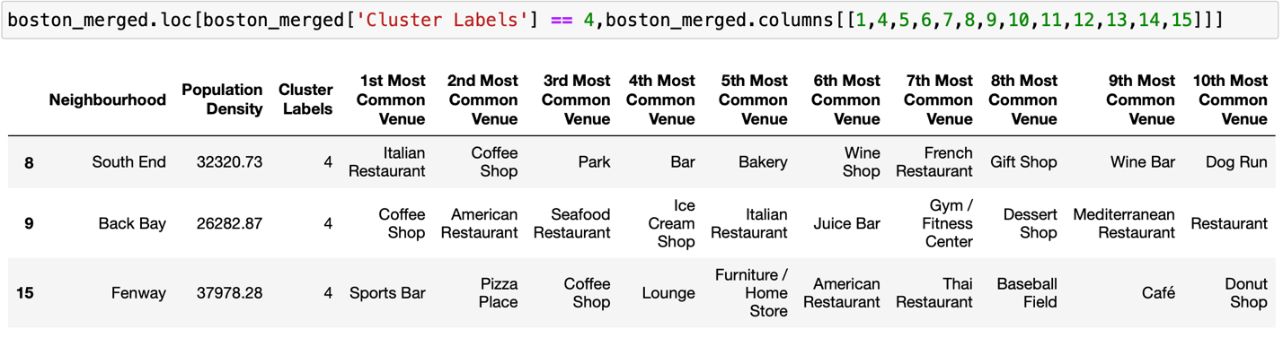

**Discussion:**

With the above analysis, it is clear that it depend on the type of the restaurant the population also provide for futher consideration. Cluster 1 may suited for Pizza place, café and Korean restaurant while Cluster 2 may suited for Chinese and Italian restaurant. Cluster 3 may suited for Pizza place, Bakery. And cluster 4 for Coffee shop and Italian restaurant.

**Limitations:**

The data may not be sufficient since the data obtain by online source may be Lack of consistency to maintain the the accuracy.

**Conclusion:**

In this project, we have gone through the various potential locations for a new restaurant in Boston through population analysis and the use of API to determine the location of existing restaurant. As per our findings, we can conclude that it depend on the type of the restaurant the population also provide for futher consideration. Cluster 1 may suited for Pizza place, café and Korean restaurant while Cluster 2 may suited for Chinese and Italian restaurant. Cluster 3 may suited for Pizza place, Bakery. And cluster 4 for Coffee shop and Italian restaurant.